CHEMICAL METHODS OF ANALYSIS

Introduction, general methods of quantitative analysis, advantages and disadvantages of the methods, principles of classical methods and instrumental methods, spectroscopic methods of analysis – properties of EMR, EM spectrum, interaction of EMR with matter and its phenomenon, various types of spectra, laws of spectrophotometry – Beer Lambert’s law, its derivation, deviations of Beer Lambert’s law, Applications of Beer Lambert’s law in qualitative and quantitative analysis, numerical problems. (4)
Introduction:
A qualitative method gives information about the identity of atomic or molecular or ionic species or the functional groups present in the sample. A quantitative method provides numerical information about the constituents, i.e., the relative amounts of one or more of the components of the sample. The quantitative methods are often classified as either classical or instrumental/modern. The classical methods are also called as wet-chemical methods.
Classical and modern/instrumental methods of analysis:
In the early years of chemistry, most analyses (which were being analyzed) were carried out by separating the components of interest by precipitation, extraction or distillation. For the qualitative study, the separated components were then treated with reagents that yielded products that could be identified by their colors, boiling or melting points, solubilities in a series of solvents, odors, optical activities or their refractive indices. These are the classical quantitative methods, which are the volumetry and gravimetry.
The phenomena other than those used for classical methods were exploited for solving the analytical problems in the early twentieth century. The measurement of physical properties of the analyte such as conductivity, electrode potential, light absorption or emission, mass-to-charge ratio, fluorescence, etc. were used for quantitative analysis. The techniques like distillation, extraction, and precipitation, etc. were replaced by high efficient chromatography and electrophoretic techniques for separation of components of complex mixtures. These newer methods for separation and determination of chemical species are collectively known as instrumental methods of analysis.
Volumetry:
In volumetric analyses, the volume or mass of a standard reagent required to react completely with the analyte will be determined by carrying out the titrations. The titration is a process used to determine the volume of a standard reagent (known concentration) required to react completely with the analyte. The analyte is also called as titrand, and the standard reagent used in the process is called as titrant. The equivalence point is the point at which the volume of the standard reagent added is chemically equivalent to the analyte with which it reacts. In volumetric analyses, the volume of the standard reagent reacted stoichiometrically with the analyte is a measuring parameter. The stoichiometric point or equivalence point may be detected by use of a visual indicator, which exhibits different colors or forms the precipitate in various media. There are four types of volumetric methods of analyses, based on the kind of reaction between the standard reagent and the analyte. They are
- Acid-Base titrations
- Complexometric titrations
- Precipitation titrations
- Redox titrations
Based on the relative nature of the acid and bases, the acid-base titrations are further classified as strong acid vs. strong base, strong acid vs. weak base, weak acid vs. strong base and weak acid vs. weak base titrations. For a particular volumetric analysis method, an appropriate (specific/selective) indicator is to be used. Some examples of indicators used in various types of volumetric analyses methods are given in the following table along with the phenomena (between the standard reagent and analyte) occurred during the titration.
Sl. No. | Type of volumetric method | Phenomena | Suitable Indicators | Examples
1 | Acid-Base titrations: | Neutralization
1 | strong acid vs. strong base | Neutralization | Phenolphthalein | HCl vs. NaOH
1 | weak acid vs. strong base | Neutralization | Phenolphthalein | CH₃COOH vs. NaOH
1 | strong acid vs. weak base | Neutralization | Methyl orange | HCl vs. NH₄OH
1 | weak acid vs. weak base | Neutralization | No suitable indicator | CH₃COOH vs. NH₄OH
2 | Complexometric titrations | Complex formation | EBT | Zn (or Ca) vs. EDTA disodium salt
3 | Precipitation titrations | Precipitation | Potassium chromate | Cl⁻ vs. AgNO₃
4 | Redox titrations | Reduction and oxidation reactions | Diphenylamine | Fe²⁺ vs. Cr⁶⁺
The essential conditions for any volumetric method of analysis are:
- The reaction must proceed to completion rapidly
- The reaction should not be complicated by additional or side reactions
- There should be a detectable change (such as a sharp change in color or formation of a precipitate) in the solution undergoing titration at the stoichiometric endpoint
- A suitable indicator must be available for detecting the endpoint.
Gravimetry:
In gravimetric analyses, the mass of the analyte or some compound produced from the analyte after treating it with appropriate reagent was determined. Gravimetric methods are based on the measurement of the mass of the analyte or the substance derived from the analyte using an analytical balance. Gravimetric methods are broadly classified as volatilization methods and precipitation methods. Volatilization methods involve the drying or heating of a sample to determine by weight of the content of volatile and or non-volatile components. Precipitation methods involve the formation of a precipitate through an appropriate reaction and weighing the precipitate. The precipitation methods generally proceed through four steps.
- Precipitation: conversion of analyte into a precipitate by an appropriate chemical using a selective reagent
- Digestion: allow the precipitate to be in contact with its mother liquor and heat it on a steam bath during which recrystallization occurs, and pure crystals/product is formed.
- Filtration: the digested precipitate will be filtered using appropriate Whatman filter papers or sintered glass crucibles, which are to be selected based on the type of precipitate and the residue forming.
- Washing, drying and weighing: the filtered precipitate is to be washed with a very dilute solution of its mother liquor then ignited followed by weighing and drying until it gives a constant weight.

Instrumental methods of analysis:
The instrumental methods of analysis are based on the measurement of various physical and or chemical properties of the analytes. These methods require the sensing probes or electronic gadgets to measure and quantify the physical/chemical property. The following are some of the methods and the corresponding measuring characteristic properties.
Sl. No. | Instrumental method | Characteristic property
1 | Kinetic methods | Rate of reaction
2 | Conductometry | Electrical resistance
3 | Potentiometry | Electrical potential
4 | Polarimetry | Rotation of radiation
5 | Refractometry | Refraction of radiation
6 | Spectrophotometry and photometry  (X-ray, UV, Visible, IR) | Absorption of radiation
7 | Emission spectroscopy | Emission of radiation
8 | Raman spectroscopy | Scattering of radiation
There is a group of instrumental procedures that are adopted for separation and resolution of closely related compounds. Most of these procedures are based on chromatography, solvent extraction or electrophoresis. One of the characteristics listed in the above table is usually used to complete the analysis following the chromatographic separations.
Some instrumental techniques are more sensitive than classical techniques. With certain combinations of elements or compounds, an instrumental method may be more selective, but with others, a gravimetric or volumetric approach may have less interference. The instrumental procedures employ more sophisticated or costlier apparatus.
Spectroscopic methods of analysis:
Spectrometric methods are a large group of analytical techniques that are based on atomic and molecular spectroscopy. Spectroscopy is a general term for the science that deals with the interactions of various types of radiation with matter. The interactions of interest were between electromagnetic radiation and matter. But now, spectroscopy has been broadened to include interactions between matter and other forms of energy such as acoustic waves, beams of particles like ions, electrons, etc. Spectrometry and spectrometric methods refer to the measurement of the intensity of radiation with a photoelectric transducer or with any other type of electronic device.
If the intensity of absorption of radiation is measured, then it is called Absorption spectroscopy. If the intensity of emission of radiation is measured, it is called Emission spectroscopy.
The most widely used spectrometric methods are based on electromagnetic radiation (the energy is mainly in the form of light and radiant heat). The other forms of energy viz., gamma rays, X-rays, U.V., microwave and radio frequency are less in usage.
General properties of electromagnetic radiation (EMR):
Many of the properties of electromagnetic radiation can be described by a classical sinusoidal wave model, which explains the parameters like wavelength, frequency, velocity, and amplitude. Unlike the other wave phenomena such as sound, electromagnetic radiation requires no supporting medium for its transmission. So it readily passes through a vacuum.
The wave model fails to account for phenomena associated with the absorption and emission of radiant energy. To understand these processes, it is necessary to consider the particle model of electromagnetic radiation in which the EM radiation is viewed as a stream of discrete packets or wave packets of energy called photons. The energy associated with the photons is proportional to the frequency of the radiation.
Electromagnetic radiation can be represented as electric and magnetic fields that undergo in-phase, sinusoidal oscillations at right angles to each other and the direction of propagation.
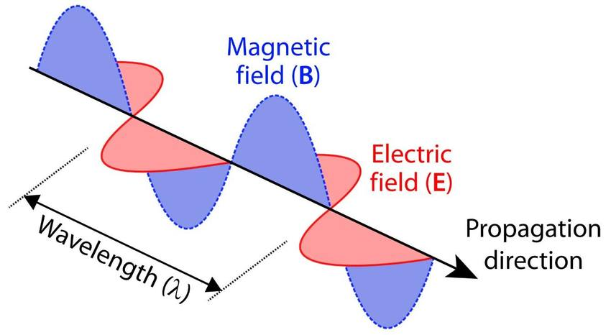
The above figure represents a single ray of plane-polarized electromagnetic radiation. The electric field strength is a vector; whose length is proportional to its magnitude. As an electric field is responsible for most of the phenomena, such as transmission, reflection, refraction, and absorption, only the electrical component of radiation will be considered. However, the magnetic component of electromagnetic radiation is responsible for absorption of radio-frequency waves in nuclear magnetic resonance.
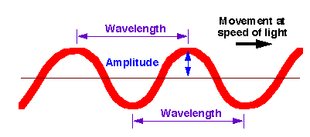
The maximum length of the electric vector is known as amplitude. The time required for the passage of successive maxima or minima through a fixed point in space is called a period (p) of the radiation. The frequency (υ) is the number of oscillations (p) of the field per second and is equal to 1/p.
υ = 1/p
Wavelength (λ) is the linear distance between any two equivalent points on successive waves. Multiplication of the frequency (in cycles per second) by the wavelength (in meters per cycles) gives the velocity of propagation.
V = υ λ
The frequency of a beam of radiation is determined by the source and remains constant. But the velocity of the radiation depends upon the composition of the medium through which it passes. Therefore, the above equation implies that the wavelength of radiation is also dependent upon the medium.
In a vacuum, the velocity of radiation is independent of wavelength and is at its maximum. This velocity is given by ‘c' and is equal to 2.99×10⁸ m/sec.
c = υ λ
υ = c / λ
In any medium containing matter, propagation of radiation is slowed by the interaction between the electromagnetic field of the radiation and the bound electrons in the matter. Since the radiant frequency is invariant and fixed by the source, the wavelength must decrease as radiation passes from a vacuum to another medium.
The wave number () is defined as the reciprocal of the wavelength in cm. and is another way of describing electromagnetic radiation. The unit for it is cm⁻¹. This is widely used in IR spectroscopy. The wave number is frequently used, because it is directly proportional to the frequency and thus the energy of the radiation.
= 1/ λ = υ/c
The Power of radiation is the energy of the beam that reaches a given area per second. The Intensity of the radiation is the power per unit solid angle. These two quantities related to the square of the amplitude and which are often used in spectroscopy.
The phenomena of refraction, reflection, constructive and destructive interference are examples of wave properties. But the wave nature of EMR fails to explain some events like photoelectric effect etc.; To justify such phenomena, it is assumed that the EMR consists of a stream of discrete packets (particles) of pure energy, called photons or quanta. These have certain energy and travel in the direction of propagation of the radiation beam with the velocity equal to that of the light. The energy of the photon is proportional to the frequency of radiation and is given by the following relationship.
E = h υ
Where E is the energy of the photon in J s, υ is the frequency of the EMR in cycles per sec., and h is called Planck’s constant (6.624×10⁻³⁴ J-sec.). The intensity of a beam of radiation is proportional to the number of photons per second that are propagated in the beam. But the intensity is independent of the energy of each photon.
Planck suggested the connection between the wave and particle characteristics of radiation. According to him, if a transition occurs between the energy states of a system such that a photon of energy E is emitted or absorbed, the frequency of the emitted or absorbed radiation is given by
E = h υ = hc
= hc/ λ
With the help of this equation, a particular wavelength or wavenumber of frequency can be converted into desired units.
Electromagnetic spectrum:
Electromagnetic spectrum encompasses an enormous range of wavelengths and frequencies (and thus energies). In fact, the range is so great that a logarithmic scale is required. The major characteristics of various regions of the spectrum are outlined as follows.
- γ-ray region:
υ = 3 EHz to 300 EHz (1 exa Hz = 10¹⁸ HZ)
λ = 100 pm to 1 pm
This region corresponds to the energy range of 1 to 100 GJ/mole. The γ-rays have sufficient energy to bring about nuclear transformations. The γ-ray resonance spectroscopy is known as Mossbauer Spectroscopy.
- X-ray region:
υ = 30 PHz to 3 EHz (1 Pet Hz = 10¹⁵HZ)
λ = 10 nm to 100 pm
This region corresponds to the energy range of 10MJ/mole to 1 GJ/mole. The energy of X-rays is sufficient to cause the transitions of core electrons of atoms and molecules. X-ray spectroscopy and X-ray photoelectron spectroscopy (XPS) is associated with the X-ray region.
- Visible and Ultraviolet region: These are further made up of the following regions.
Vacuum ultraviolet: 1 – 800 nm
Ultraviolet: 180 – 400 nm
Visible: 400 – 750 nm
- Infrared region: This region has been further divided into the following sub-regions.
Infrared (near) : 0.7 – 2.5 μ
Infrared: 2.5 – 15 μ
Far infrared: 15 – 200 μ
- Microwave region: (0.1 mm to 1 cm wavelength) This region corresponds to changes in the rotation of molecules. Separations between the rotational levels of molecules are of the order of hundreds of joules per mole.
- Radiofrequency region: (10 m – 1 cm wavelength) The energy change involved in this region arises due to the reversal of a spin of nucleus or electron. This is of the order 0.001 – 10 J/mole.
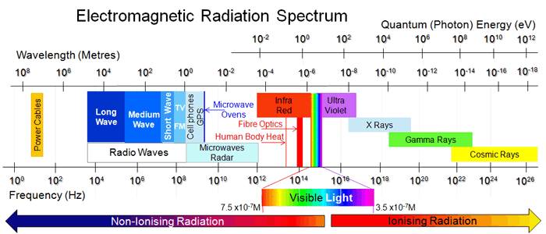
Interaction of EMR with matter:
When EMR passes through matter, a variety of phenomena may occur. Some of these are as follows.
If the photons of radiation possess the appropriate energies, they may be absorbed by the matter and result in electronic transitions, vibrational changes or rotational changes or combination of these. After absorption, atoms or molecules become excited. They give out energy quickly either by losing energy in the form of heat or by re-emitting EMR.
It is not necessarily that the radiation passing through the matter may be absorbed completely. The portion of EMR which passes into the matter, instead of being absorbed, may undergo scattering or reflection or may be re-emitted at the same wavelength or a different wavelength.
When EMR is neither absorbed nor scattered, it may change orientation or polarization.
In some cases, the molecules after absorbing radiation become excited, but they do not lose energy very quickly but with some delay. In such cases, the energy is re-emitted as radiation usually of longer wavelength than was initially absorbed. This phenomenon is called as fluorescence. If in some cases, there is a detectable time delay in re-emission, the phenomena are termed as phosphorescence.
Molecular spectroscopy:
In molecular spectroscopy, the spectra arise from three types of transitions viz., rotational, vibrational and electronic transitions. The total energy of a molecule is given by the following equation according to Born-Oppenheimer approximation,
E_{total} = E_{translational} + E_{rotational} + E_{vibrational} + E_{electronic}
The molecular energy is the sum of translational energy, rotational energy, vibrational energy and electronic energy. The translational energy is not quantized and furthermore,
E_{electronic} >> E_{vibrational} >> E_{rotational} >> E_{translational}
Since the translational energy is negligibly small, we can write the Born-Oppenheimer approximation as
E_{total} = E_{rotational} + E_{vibrational} + E_{electronic}
Let us illustrate these energies concerning a diatomic molecule. Rotational energy arises when the molecule rotates about an axis perpendicular to the internuclear axis and passing through the center of gravity of the molecule. Vibrational energy is associated with the to and fro motion of the nuclei of the molecule such that the center of gravity does not change. Electronic energy is associated with the transition of an electron from the ground energy level to an excited state energy level of the molecule due to the absorption of a photon of suitable frequency.
Each electronic energy level (designated with E) is associated with a series of vibrational energy levels (assigned with the vibrational quantum number, v) and each vibrational energy level is related to a set of rotational energy levels (designated with R) as shown in the following fig.
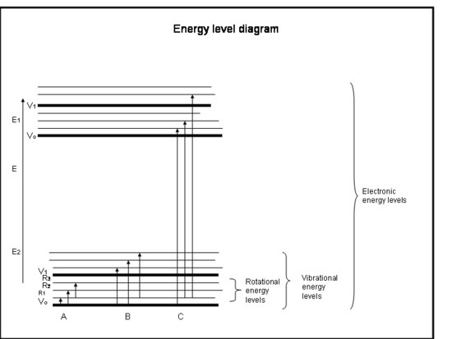
The rotational spectra of a molecule are observed in the microwave region, the vibrational spectra in the infrared (IR) region and the electronic spectra in the ultraviolet (UV) and or visible regions of the electromagnetic spectrum.
The various types of spectra given by a molecule, the regions in which these spectra lie and the energy that takes place in the molecule on the absorption of radiation are listed below.
Rotational (Microwave) spectra: These spectra result from transitions between the rotational energy levels of a gaseous molecule on the absorption of radiations falling in the microwave region. These spectra are shown by the molecules which possess a permanent dipole moment, e.g., HCl, CO, H₂O vapor, NO, etc. Homonuclear diatomic molecules like H₂, Cl₂, etc., and linear polyatomic molecules such as CO₂ which do not possess a dipole moment, do not show microwave spectra. Microwave spectra occur in the spectral range of 1 – 100 cm⁻¹.
Vibrational and vibration-rotation (Infrared) spectra: These spectra originate from transitions induced between the vibrational energy levels of a molecule on the absorption of radiations belonging to the infrared region. IR spectra are shown by molecules when vibrational motion is accompanied by a change in the dipole moment of the molecule. These spectra occur in the spectral range of 400 – 4000 cm⁻¹.
Electronic spectra: Electronic spectra arise from an electronic transition in a molecule by absorption of radiations falling in the visible and ultraviolet regions. While electronic spectra in the visible region span 12,500 – 25000 cm⁻¹, those in the ultraviolet region span 25000 – 70000 cm⁻¹. Since vibrational and rotational transitions invariably accompany electronic transitions in a molecule, the electronic spectra of molecules are highly complex.
Spectrophotometry:
Beer and Lambert’s law and its derivation:
When a monochromatic light of initial intensity Io passes through a solution in a transparent vessel, some of the light is absorbed so that the intensity of the transmitted light I is less than Io. There is some loss of light intensity from scattering by particles in the solution and reflection at the interfaces, but mainly from absorption by the solution. The relationship between I and Io depends on the path length of the absorbing medium, b and the concentration of the absorbing solution, c. These factors are related to the laws of Lambert and Beer.
Lambert’s law
When a ray of monochromatic light passes through an absorbing medium, its intensity decreases exponentially as the length of the medium absorbing increases.
Beer’s law
When a monochromatic light passes through an absorbing medium, its intensity decreases exponentially as the concentration of the medium absorbing increases.
Transmittance
The ratio of intensities is known as the transmittance (T), and this is usually expressed as the percentage.
Derivation:
When a beam of monochromatic radiation of a suitable frequency passes through a solution, it is absorbed by the solution. As a result, the intensity of the light when it finally emerges from the solution is considerably reduced. If I₀ is the intensity of the incident beam and It is the intensity of the transmitted beam, then the intensity of the light absorbed, Ia is given by
I_{a} = I₀ – I_{t} ……… (1)
The intensity of the beam is defined as the energy falling on unit area perpendicular to the beam per unit time. It is proportional to the number of photons incident on the unit area in unit time.
The probability that the photons of a beam of intensity I will be absorbed by the sample is directly proportional to the concentration and thickness of the absorbing solution, and it can be expressed as
dI/I = -αcdx …………. (2)
Where dI is the change is the change in intensity produced by the absorption of radiation on passing through a thickness dx of the solution of concentration c and α is the proportionality constant. Minus sign is introduced as there is a reduction in intensity.
Integration of Eq 2. between limits I =I₀ at = 0 and I = I & x =b gives,
ln (I/I₀) = 2.303 log (I/I₀) = - αbc ………….. (3)
According to eq 3, the intensity of a beam of monochromatic radiation decreases exponentially with an increase in the thickness x and the concentration c of the medium. This is Beer-Lambert law.
Putting α/2.303 = ε and defining log (I₀/I) as absorbance, A of the solution, we get
A= log (I₀/I) = εbc ………….. (4)
In equation 4, the ε is called the extinction coefficient of the absorbing medium. It is the characteristic of the solute and depends on the nature of the solvent, temperature, and wavelength of the radiation employed. When the concentration is expressed in mol dm-3 and the path length in cm, then ε is expressed in dm³ mol⁻¹ cm⁻¹ is referred as molar absorption coefficient or molar extinction coefficient.
Limitations of the Beer-Lambert law:
Chemical and instrumental factors limit the linearity of the Beer-Lambert law. The probable causes of nonlinearity are:
- Deviations in absorptivity coefficients at high concentrations (>0.01M) due to electrostatic interactions between molecules nearby
- Scattering of light due to particulates in the sample
- Fluorescence or phosphorescence of the sample
- Changes in refractive index at a high analyte concentration
- Shifts in chemical equilibria as a function of concentration
- Non-monochromatic radiation, deviations can be minimized by using a relatively flat part of the absorption spectrum such as the maximum of an absorption band
- Stray light
Applications of Beer Lambert's law in the qualitative and quantitative analysis:
Estimation of Iron:
Iron is one of the many minerals required by the human body. It is biologically relevant as oxygen-carrying proteins, hemoglobin and myoglobin. A deficiency of iron in the body can leave a person feeling tired and can lead to a disorder called anemia. Many of the foods we eat contain small quantities of iron. The trace quantity of iron also may be present in water sources. Another application of iron is in industrial metallurgy. So, a simple method to estimate iron at very low concentrations is desired using colorimetric analysis.
Method:
In this analysis the iron present in the samples (like an iron tablet or a sample of food is extracted to form a solution containing Fe³⁺ (ferric) ions. To make the presence of these ions in solution visible, thiocyanate ions (SCN⁻) are added. These react with the Fe³⁺ ions to form a blood-red colored complex as given below.
Fe³⁺(aq) + SCN⁻(aq) → [FeSCN]²⁺(aq)
By comparing the intensity of the color of this solution with the colors of a series of standard solutions, with known Fe³⁺ concentrations, the concentration of iron in the tablet, food or any other sample may be determined. A plot of absorbance vs. solution of known concentration and then by comparison of the absorbance of the unknown solution, one can quantitatively estimate the amount of iron irons present.
Numerical:
The molar extinction coefficient of phenanthroline complex of iron (II) is 1200 dm³ mol⁻¹ cm^{-1,} and the minimum detectable absorbance is 0.01. Calculate the minimum concentration of the complex that can be detected in the experiment if the path length is 1.00 cm.
A = εbc
c = A/εb = 0.01 / 1.00 * 1200
= 8.33 x 10⁻⁶ M
***

